Rittal CS Toptec outdoor enclosure
Standardised, twin-walled and bayable
Herborn/Hannover, 2024-04-23
Changing requirements demand fast and straightforward solutions – that also applies to the installation of outdoor enclosures. The evolution of the Rittal CS Toptec range now standardises the principle of Rittal large enclosures with the simple bayed design of twin-walled outdoor enclosures. With convincing benefits: plant manufacturers benefit from fast availability, versatile expansion options, and flexible on-site installation.
In the past, special designs were generally the means of choice when plant manufacturers were looking for a twin-walled and very wide outdoor enclosure. With correspondingly negative consequences: high costs, long delivery times, and complex installation. Rittal now offers a solution to this with the evolution of its CS Toptec outdoor enclosure. In doing so, the manufacturer has transferred the principle of its bayed enclosures to twin-walled outdoor enclosures. They are now being volume-produced and so are available ex-stock in widths of 600 and 800 mm, depths of 600 and 800 mm, and heights of 1,200, 1,600, 1,800 and 2,000 mm – optionally with a cut-out for a cooling unit. Thus, instead of opting for a single wide and heavy enclosure, plant manufacturers can select two or more slim individual enclosures and also further add to them at any time later on. This gives them greater flexibility, simplifying logistics as well as installation on-site.

Delivery times are significantly shorter – Rittal’s 24- or 48-hour delivery promise also applies to the CS Toptec. Plant manufacturers can, therefore, respond immediately to changing requirements without having to take into account lengthy planning, design and production delays.
Maximum flexibility ex-stock
Rittal is focusing in particular on the diverse expansion options of the enclosures by the use of an extensive range of system accessories and versatile installation on site. Technical work on site is kept to a minimum by the straightforward bayed design of the enclosures. Door hinges can also be independently changed on-site if required. As Rittal also supplies a wide range of custom-fit outdoor cooling solutions, such as the Blue e+ outdoor cooling units, appropriately prepared enclosures can be ordered.

Thanks to their durability and modular design, Rittal outdoor enclosures also ensure the sustainable use of resources and low total cost of ownership throughout the product's service life.
Digital wiring plan pocket always to hand
The paperless ePOCKET equipment and system documentation ensures up-to-date access to all key information. As with every Rittal enclosure, this digital wiring plan pocket is also integrated into the CS Toptec, giving customers easy access via the Eplan Cloud. Inspections and information exchange can thus be carried out quickly and efficiently.

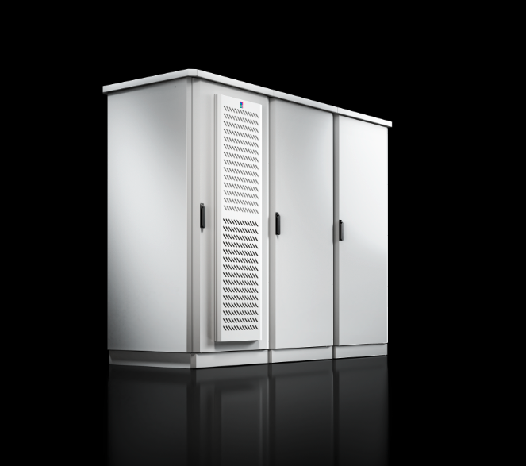
Caption
Image 1 (fri230417100): Series production and the individual expansion options of the bayable CS Toptec go hand in hand with a host of new benefits, particularly in terms of delivery time and flexibility.

May be reproduced free of charge. Please name Rittal GmbH & Co. KG as source.

Rittal

Rittal is a leading global supplier of enclosure systems, automation and infrastructure with its industrial, IT, energy and power, cooling and service units. Rittal products and solutions are used in over 90% of global industries – standardised, customised, and always of the very best quality.
Our approach and methodology: Rittal, Rittal Software Systems (Eplan, Cideon and German Edge Cloud) and Rittal Automation Systems (RAS, Ehrt, Alfra) combine their hardware and software expertise to streamline, optimise and digitalise processes across the entire value chain for our customers including their IT infrastructure – from control and switchgear construction, machine building to factory operators or the energy sector.
Our delivery promise: Rittal standard products are delivered in Germany within 24 hours, and within 48 hours throughout Europe.
Customer focus
Improving efficiency and increasing productivity through automation and digitalisation is one of the biggest challenges for our customers. This requires in-depth knowledge and expertise, the combination of hardware and software, and cross-sector networking. We are convinced that creating and connecting data rooms is crucial to the success of industrial transformation. And that is exactly our speciality and field of competence.
Eplan and Rittal are driving the development of the digital automation twin, making data accessible and useable in operations as well. Cideon is improving data consistency in the digital product twin context with its CAD/CAM, PDM/PLM and product configuration expertise. German Edge Cloud’s ONCITE Digital Production System (DPS) makes production process data transparent, enabling it to be optimised – right through to energy management using digital production twins.
Sustainability
Environmental and climate protection, social commitment and ethical corporate management are a given for Rittal. We take our responsibility for a sustainable future seriously. Our approach to resource management and conservation involves continuous improvement of our own production processes and ensuring that our products have the lowest possible Product Carbon Footprint. Our solutions support our customers in achieving their own climate targets.
Family business and global player
Founded in 1961, Rittal is the largest company in the owner-operated Friedhelm Loh Group. The group operates worldwide, with more than 12 production sites and over 95 international subsidiaries. It has more than 12,100 employees and posted revenues of 3 billion euros in fiscal 2023. In 2023, the Friedhelm Loh Group was presented with the “Best Place to Learn” and “Employer of the Future” awards. In 2024, Rittal was awarded the Top 100 Seal as one of Germany’s most innovative medium-sized companies for the third time in a row.
For more information, visit www.rittal.com and www.friedhelm-loh-group.com.

Corporate Communications
Dr. Carola Hilbrand Rittal GmbH & Co. KG
Corporate & Brand Communications Auf dem Stützelberg
Tel.: 02772/505-2527 35745 Herborn
hilbrand.c@rittal.de www.rittal.com


Follow us:

